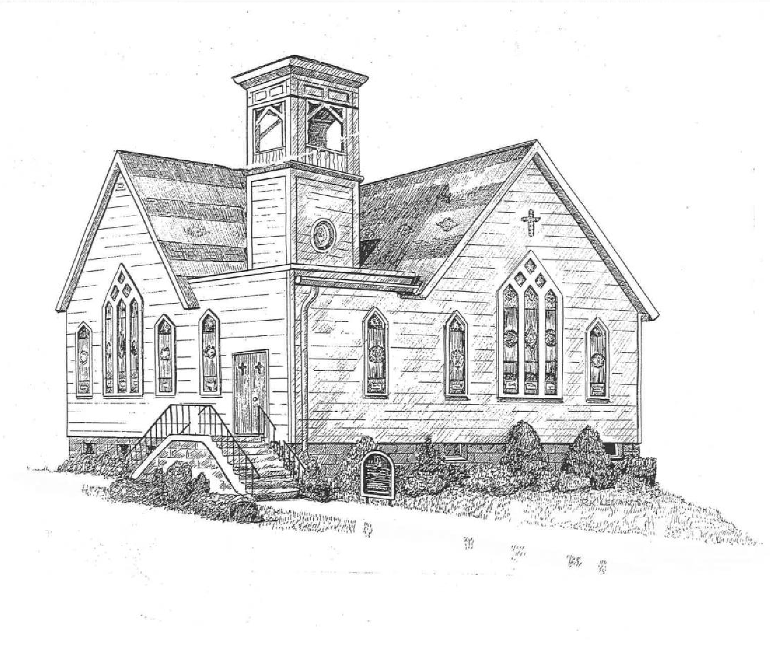

CENTER BRUNSWICK
UNITED METHODIST CHURCH
Pastor
990 Hoosick Road, Troy, New York 12180
Church: (518) 279-9705
http://www.centerbrunswickumc.org
Lay Leader: Lori Holmes
Musician: Owen Greene
Bell / Chimes Choir Director: Kathy Hoffman
Pastor-Parish Relations: David Little

August 23rd, 2026
Forth Sunday After Pentecost

GATHERING FOR WORSHIP
PRELUDE

WELCOME AND ANNOUNCEMENTS

OPENING HYMN: The Church’s One Foundation #545

OPENING PRAYER

*HYMN: God will Take Care of You # 130

CENTERING FOR WORSHIP

*CALL TO WORSHIP
L: God has cared for us through every season and created each of us with purpose.
P: We gather with gratitude, ready to offer the gifts we have received.
L: Though we are different, we are members of one body in Christ.
P: We need one another, and together we can share God’s love with the world.
L: Let us listen for the voice that calls us beloved, gifted, and needed.
P: Let us worship God as the people we were created to be!
Amen!

* PRAYER OF INVOCATION
Gracious and loving God,
Come among us through your Holy Spirit and awaken us to your presence. Quiet the voices that compare, confine, and diminish us. Renew our minds so that we may see ourselves and one another through the eyes of grace.
Help us recognize the gifts you have placed within every life—including those gifts that are quiet, unnamed, or still developing. Give us the courage to become more fully the people you created us to be, and the humility to offer ourselves in service rather than seeking recognition.
Shape us into one body, united in Christ and overflowing with compassion for the world.
Amen.

PROCLAMATION OF THE WORD

SCRIPTURE:
Romans 12:1–8
Matthew 16:13–20
*HYMN: Where Charity and Love Prevail v1-4 # 549

THE WORD OF GOD EXPLORED
Who God Created You to Be
Lay Speaker: April Snow

OFFERTORY
*DEDICATION OF TITHES AND OFFERINGS
*DOXOLOGY
PRAYERS OF THE PEOPLE AND PASTOR

COMMUNION: Service of Word and Table III (Page 15 UM Hymnal)

THE LORD’S PRAYER
Our Father, who art in heaven, hallowed be thy name. Thy kingdom come; thy will be done on earth as it is in heaven. Give us this day our daily bread. And forgive us our trespasses, as we forgive those who trespass against us. And lead us not into temptation but deliver us from evil. For thine is the kingdom, and the power, and the glory, forever. Amen.

*HYMN: Title # XXXX

*BENDICTION

POSTLUDE:
*Indicates standing if that is comfortable for you. **********************************************

